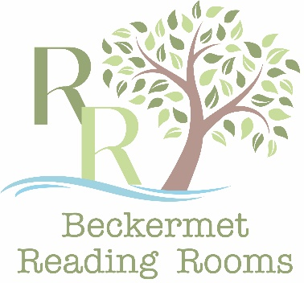

Beckermet Reading Rooms Community Interest Company (CIC)
- Rates of Hire
The Reading Rooms is a community facility that is intended to be free of charge for non-profit making community events and groups, notwithstanding it must also generate sufficient income to sustain its services. Please check the applicable rate of hire prior to confirming a booking. It is normal practise that a short period prior to and following a booking for setting-up etc will not incur a charge.
The Reading Rooms is licensed to sell alcohol, only alcohol sold under this licence can be served in the Reading Rooms.
All hirers are expected to clean and leave the Reading Rooms as they were found, ready for the next user, unless a cleaning/setup service has been requested or is included in the rate of hire (see below).
Community Rates
Private Parties
The rate of hire for private events is £15 per hour, or £100 for a full 8-hour day, with additional hours at a rate of £10 per hour.
A cleaning and setup/clear-away service can be provided at a cost of £25.
If the Bar Service is required, then this will incur a cost of £25, plus purchases at the normal rates.
A non-refundable deposit of 50% will normally be required for Private Party bookings.
Community Groups/Fundraisers
The rate of hire for Community Groups that charge an entry fee or generate income by any means is £15 per hour; a discount may be agreed by the CIC on application.
Community Events
Community Events that are open to all, make no entry charge and do not generate income via any means use the Reading Rooms free of charge.

Commercial Rates
Pilot Event Discount
The organiser(s) of new starter events that will repeat, such as a weekly exercise or writing class, who wish to test/assess the demand for their event, may apply for a Pilot Event Discount. The discount will normally be 50% of the costs for Supported or Unsupported event prices (see below),and may be agreed for up to three successive events.
Supported
Supported events are those where marketing is provided by the Reading Rooms, and the tickets for the event are sold and managed by the Reading Rooms on behalf of the event organiser. In this case there is an administration fee of £20 for the event, and the rate of hire is £15 per hour.
Unsupported Events
Unsupported events are where all marketing and the management of the event is undertaken by the event organiser. In this case the rate of hire is £15 per hour.
Reading Rooms Events
When an event provider is engaged and paid by the Reading Rooms (for example a band), the marketing, ticket sales and management of the event are undertaken by the Reading Rooms. Money made from tickets sales will subsidise the overall funding of the event, and any surplus made will contribute to the running costs of the Reading Rooms.

Conference & Meetings
Room Only
The basic rate of hire for commercial purposes is £150 per day, or £100 per half-day. The maximum capacity is 16 delegates in conference style, or 25 delegates in theatre style. The rate is inclusive of tables, seating, super-size TV screen display including sound connectivity, reasonable use of WiFi and a cleanup/setup service.
Room plus Refreshments
As per the Room Only rate, plus an additional rate of £2 for half-days bookings, or £3 for full day bookings (per person), this includes tea, coffee, still/sparkling water, and biscuits.
Room plus Refreshments & Lunch
As per the Room Only rate, plus an additional rate of £12 (per person), this includes a sandwich-buffet lunch and fresh cake(s), tea, coffee, still/sparkling water, and biscuits.

Where entry is by invitation.
That does not provide income to the CIC.

